First Wave ISAC Beacon Assembly Guide

By Cameron G.

The following is a guide to creating and assembling the parts required to make the First Wave ISAC Beacon, a replica of the Integrated Systems Analytic Computer (ISAC) shoulder radio beacon used by SHD Agents in Tom Clancy’s: The Division franchise. Intended purpose of the First Wave ISAC Beacon is to give fans of The Division a way to show off their love of the game through Cosplay at conventions or just wearing it around for fun. Although it took a lot of time and effort to develop the software and circuitry used in the First Wave version of the ISAC beacon, I saw it as a challenge to do something fun and learn new skills along the way. I hope you enjoy and are excited about the result as I am.

-Cameron G.

Contents

Parts List 3

3D Printing 3

Main Housing and Baseplates 4

Antenna and cable parts 5

ISAC light ring parts 6

Finishing and smoothing the 3D prints to remove print lines 6

Painting the 3D parts 7

Electronic Circuit 8

Specific circuit elements 8

Capacitors 8

Resistors 9

Soldering considerations 9

Deploying the software and audio files to the circuit 10

Install the Arduino IDE, NeoPixel, and DFPlayer libraries 11

Deploying the software to the Adafruit Pro Trinket 12

Copy audio files to the Micro SD card 12

Testing the circuit 12

Assembly 13

ISAC Light Ring 13

Push Buttons 16

Speaker 18

Antenna 19

Antenna Arm 20

Cable Port Wire 23

Circuit Installation 23

Baseplate 25

Attaching to Backpack 26

# Parts List

|  |  |  |  |
| --- | --- | --- | --- |
| Qty | Part |  |  |
| 1 | Adafruit Pro Trinket 5V 16MHz |  | [Digikey.com](https://www.digikey.com/product-detail/en/adafruit-industries-llc/2000/1528-1039-ND/4990788) |
| 1 | NeoPixel 16 ring (WS2812) |  | [Digikey.com](https://www.digikey.com/product-detail/en/adafruit-industries-llc/1463/1528-1093-ND/5154668) |
| 1 | 3-Watt 8 Ohm speaker (must fit inside front housing) | [Amazon.com](https://www.amazon.com/gp/product/B07FTB281F/ref=ppx_yo_dt_b_asin_title_o07_s00?ie=UTF8&psc=1) |  |
| 1 | DFPlayer Mini MP3 player and Micro SD reader module | [Amazon.com](https://www.amazon.com/gp/product/B01D1D0E7Q/ref=ppx_yo_dt_b_asin_title_o08_s00?ie=UTF8&psc=1) | [Digikey.com](https://www.digikey.com/short/pfvfcm) |
| 2 | Mini Micro JST 2.0 Ph 3 Pin male & female connector w/ cables | [Amazon.com](https://www.amazon.com/gp/product/B01DUC1PW6/ref=ppx_yo_dt_b_asin_title_o05_s00?ie=UTF8&psc=1) |  |
| 1 | Mini Micro JST 2.0 Ph 2 Pin male | [Amazon.com](https://www.amazon.com/gp/product/B01DUC1O68/ref=ppx_yo_dt_b_asin_title_o05_s00?ie=UTF8&psc=1) | [Digikey.com](https://www.digikey.com/product-detail/en/jst-sales-america-inc/B2B-PH-K-S-LF-SN/455-1704-ND/926611) |
| 1 | 12.5cm black 22 AWG hook up wire |  | [Digikey.com (1’ cable)](https://www.digikey.com/product-detail/en/te-connectivity-raychem-cable-protection/22759-32-22-0/22759-32-22-0-DS-ND/2399853) |
| 2 | 12x12x7.3mm Momentary Tactile Push Button Switch with Cap | [Amazon.com](https://www.amazon.com/gp/product/B01NCQVGLC/ref=ppx_yo_dt_b_asin_title_o05_s01?ie=UTF8&psc=1) | [Digikey.com (cap)](https://www.digikey.com/product-detail/en/apem-inc/AKTSC22K/679-2315-ND/2344068) [Digikey.com (switch)](https://www.digikey.com/product-detail/en/te-connectivity-alcoswitch-switches/FSM103/450-1158-ND/701085) |
| 1 | 14” long of 3/4” black heat shrink tubing | [Amazon.com](https://www.amazon.com/gp/product/B07CVXZN4P/ref=ppx_yo_dt_b_asin_title_o05_s01?ie=UTF8&psc=1) |  |
| 1 | J-B KwikWeld epoxy (mostly for antenna strength) | [Amazon.com](https://www.amazon.com/gp/product/B009EU5ZM0/ref=ppx_yo_dt_b_asin_title_o05_s01?ie=UTF8&psc=1) |  |
| 1 | MicroSD card | [Amazon.com](https://www.amazon.com/gp/product/B079H6PDCK/ref=ppx_yo_dt_b_asin_title_o09_s00?ie=UTF8&psc=1) |  |
| 1 | 3ft USB Micro cable |  | [Digikey.com](https://www.digikey.com/product-detail/en/stewart-connector/SC-2AMK003F/380-1431-ND/8544577) |
| 1 | Black Matte Finish spray paint | [Amazon.com](https://www.amazon.com/Krylon-K05592007-COLORmaxx-Spray-Aerosol/dp/B07LFXGDWK/ref=sr_1_5?crid=1452ZSADIPTEM&keywords=black+matte+spray+paint&qid=1569088127&sprefix=black+matte+s%2Caps%2C217&sr=8-5) |  |
| 1 | Clear ABS 3D Printer Filament | [Amazon.com](https://www.amazon.com/gp/product/B07CZ6S9K5/ref=ppx_yo_dt_b_asin_title_o03_s01?ie=UTF8&psc=1) |  |
| 1 | Novamaker Black ABS 3D Printer Filament | [Amazon.com](https://www.amazon.com/NOVAMAKER-ABS-1KG1-75-BlK-Filament-Dimensional-Accuracy/dp/B0746CVBK9/ref=sr_1_3?crid=XTHZGOI67XMZ&keywords=black+novamaker+abs&qid=1689630406&sprefix=black+novamaker+ab%2Caps%2C150&sr=8-3) |  |
| 2 | 100k Ohm resistor |  | [Digikey.com](https://www.digikey.com/product-detail/en/stackpole-electronics-inc/CF14JT100K/CF14JT100KCT-ND/1830399) |
| 1 | 1k Ohm resistor |  | [Digikey.com](https://www.digikey.com/product-detail/en/stackpole-electronics-inc/CF14JT1K00/CF14JT1K00CT-ND/1830350) |
| 2 | 6.3v 330uFl capacitors |  | [Digikey.com](https://www.digikey.com/product-detail/en/united-chemi-con/APSA6R3ELL331MFA5G/565-3063-ND/758494) |
| 2 | Velcro hook and loop ties |  | [Digikey.com](https://www.digikey.com/product-detail/en/panduit-corp/UCT3S-X0/298-4011-ND/1306570) |
| 4 | M2.5x6 screws (228-206-2) |  |  |
| 5 | 8-32x ½” screws (081-B03-2) |  |  |
| 1 | 8-32 x 1” black socket head screw |  |  |
|  |  |  |  |
|  | **Optional Parts** |  |  |
| 1 | DFRobot FTDI basic Breakout module 3.3/5V |  | [Digikey.com](https://www.digikey.com/products/en?keywords=dfr0065) |
| 1 | Wide black money clip (if using the clip baseplate) | [Amazon.com](https://www.amazon.com/Travelambo-Carbon-Pocket-Minimalist-Business/dp/B01N35XJXP/ref=sr_1_25?keywords=wide+money+clip&qid=1569088563&sr=8-25) |  |

Generally, Digikey.com has lower prices and allows you to buy some of the parts individually rather than in a bulk package such as Resistors and Capacitors. So, for the parts you can get from Digikey.com, I recommend them or going to your local electronics store if you are just making one or two ISAC beacons. Some items I was only able to find on Amazon in a package such as the 3 pin connectors and wires and the speaker that fits nicely into the housing.

# 3D Printing

The 3D models are modified from the following two authors on Thingiverse.com and I appreciate the work that they did in their versions of the beacon.

[MZD471](https://www.thingiverse.com/MZD471) - [Tom Clancy's The Division Functional Comms Module](https://www.thingiverse.com/thing:1327053)  
3D model used as the base of the First Wave version. Modified housing for buttons, shorter radio antenna, and edited to be one printed piece for the top and one separate piece for bottom.

[guido666](https://www.thingiverse.com/guido666) - [The Division - Shoulder Beacon v3](https://www.thingiverse.com/thing:1411233)  
Parts of the 3D antenna were used to crate my own version and well as the code provided for learning how to work with the NeoPixel ring.

I’ve modified the housing so that it comes as one upper piece and a baseplate. This reduced the amount of gluing and other issues I ran into while constructing the initial prototype. Best printing orientation is as shown below using supports and optionally a raft (especially for the top housing). These should be printed with Black ABS 3D printers and not PLA.

## Main Housing and Baseplates

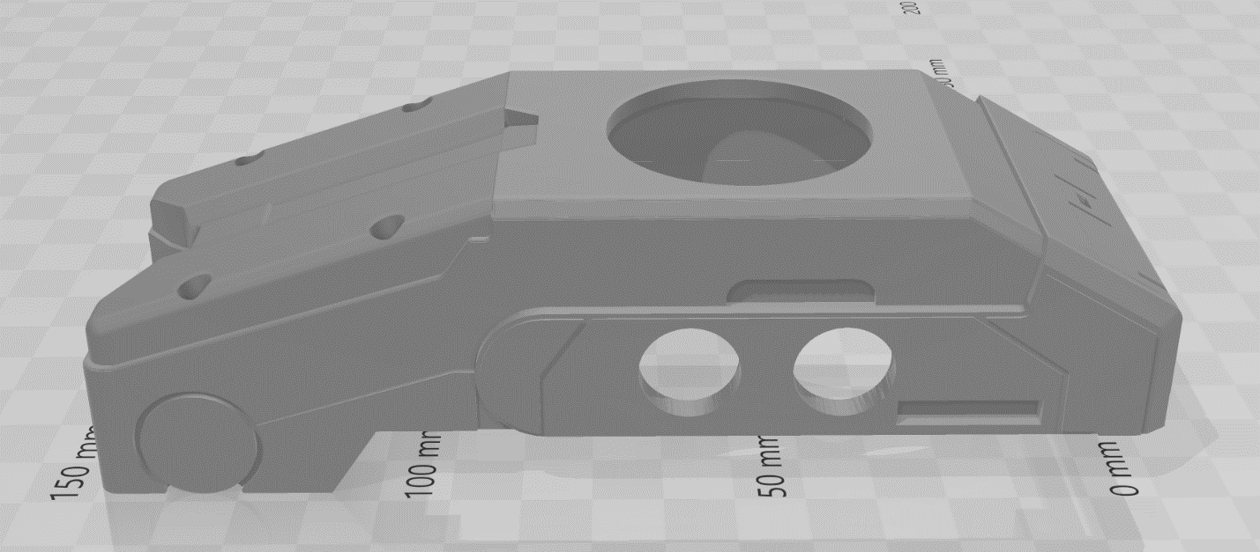

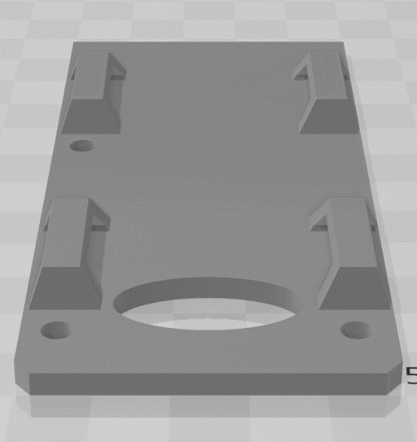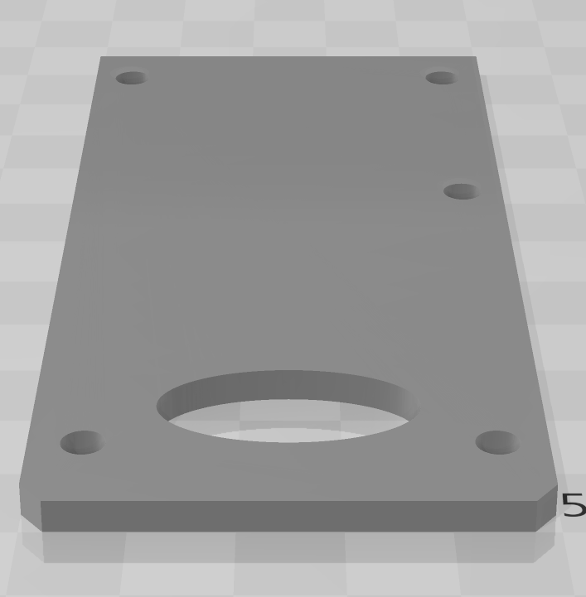

(Left) Baseplate with integrated loops  
(Right) Baseplate to epoxy a clip onto

By having a removable baseplate, it added the following benefits:

1. The internal components are easier to insert and fit into the housing.
2. If something were to go wrong after assembly, you could now access the internals to fix it
3. A removable baseplate allows the builder to choose how they want to attach their ISAC beacon to their backpack. Either by clip or by built-in loops of the baseplate.

I have constructed both and both clip and loops work great. I find the loops better if your backpack strap has Molle webbing on the shoulders already and makes the ISAC beacon sit flush on the strap. The clip is more in line with what the in-game model has (see below). The clip is versatile to attach to many other objects, but some of the clips I tested made the beacon sit higher up and wiggle more than the loops. You may want to print and try both to see what works for your setup best.

## Antenna and cable parts

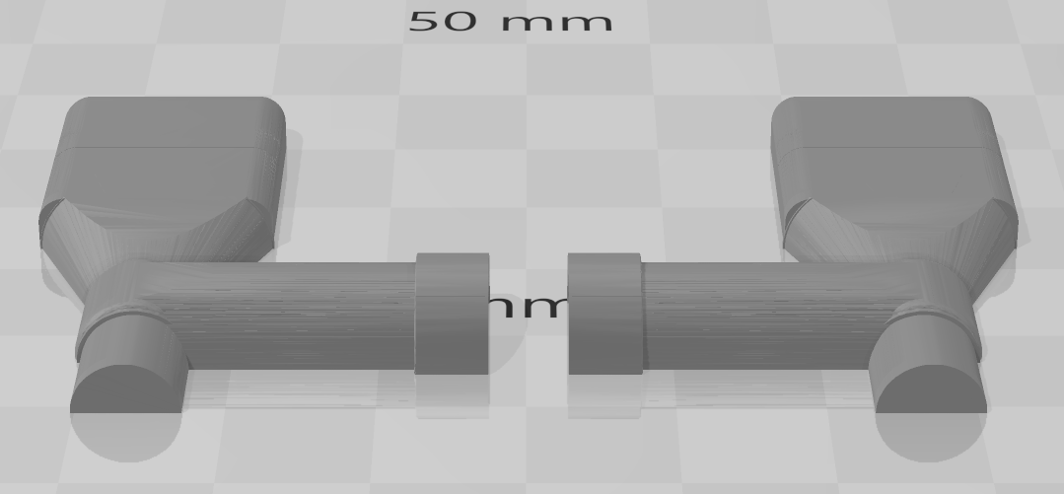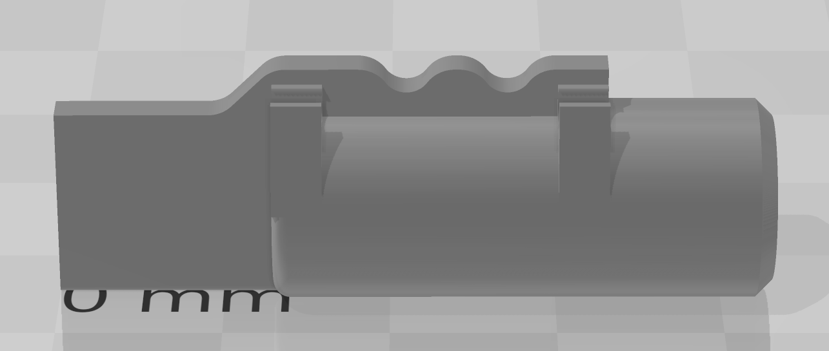 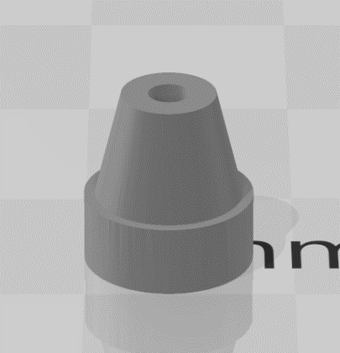

(Top) Main antenna arm  
(Bottom left) Antenna bottom  
(Bottom right) Cable port

The main antenna arms are printed in half sections that are then glued together using the J-B KwikWeld epoxy. I have included a cavity within the arm where an 8-32 x 1 socket head screw can be inserted and surrounded with the epoxy when assembling the pieces to further strengthen the antenna arm. This allows the arms to be stronger and not break as easily if the antenna gets bumped once assembled. You will also want to use the epoxy to secure the antenna arm to the main housing. The antenna bottom is also glued onto the end cap as pictured. The cable port fits on the side of the beacon’s main housing and is where the wire cable comes out of. Make sure when importing the models that all units are in mm to ensure proper size when printing.

## ISAC light ring parts

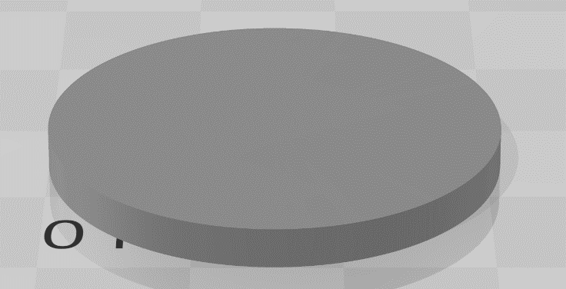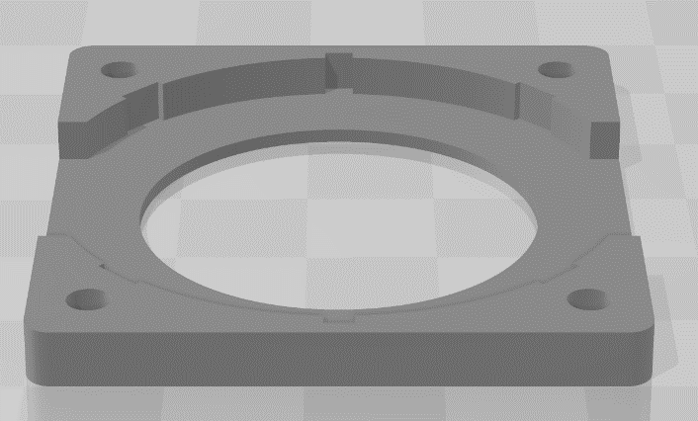

(Top Left) Ring mid plate  
(Top right) Ring window (printed with transparent material)  
(Bottom left) NeoPixel base plate  
(Bottom right) Diffuser (printed with transparent material)

These parts make up the housing and windows for the LED ring. The ring window and diffuser must be printed with clear ABS material so the light can easily go through them. Do not use filler, primer, or paint on the window and diffuser.

## Finishing and smoothing the 3D prints to remove print lines

Depending on your print settings, you may have small lines or groves. If your print looks good, you can leave it as-is, but you can also smooth out these lines in various different ways that can be looked up on the internet including acetone vapors, sanding, or using a filler. In my latest prints, I do not do any finishing other than a light sanding on some rough parts as I believe it looks good and is far less work (especially when printed in black filament).

But my first model did not have a choice of filament color and eded up with pink and red pieces, so I used a filler and primer with a little bit of sanding worked very well. It just took a lot more work than was probably needed. The trick with filler is to only use 1 or 2 light coats, the more you add the more sanding you will end up needing to do. The filler covers the groves and then with a small bit of sanding will take off the other filler that piled up on the top of the groves. Below are some pictures demonstrating this. I used 150 grain sandpaper for the initial sanding after the filler had dried and then use 200 grain to get it to a nice fine smoother finish. I’m not perfect and there are still some crevices and lines, but overall, I’m pleased with it and the paint also fills in a bit as well. You may need to take a sharp point or nail and dig the primer out of the detail cervices along the sides of the beacon near the front. You don’t want those to be filled in and lose the detail of the print.

The base plate doesn’t even need any primer or filler as it won’t be seen much. Same with the NeoPixel base plate as it will sit inside. You will want to finish and sand the antenna arms as well once glued.

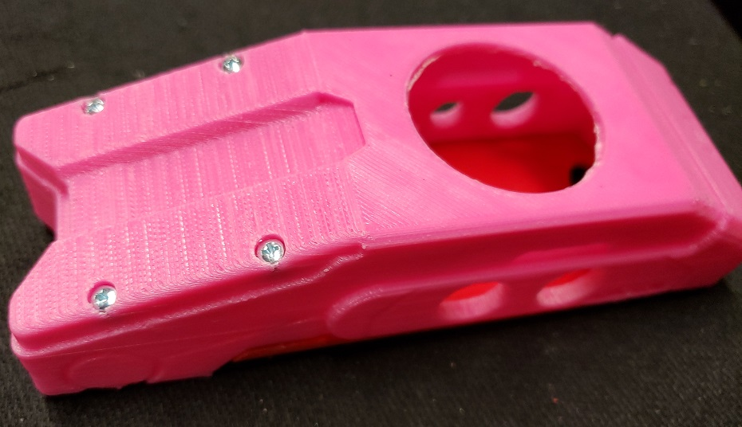 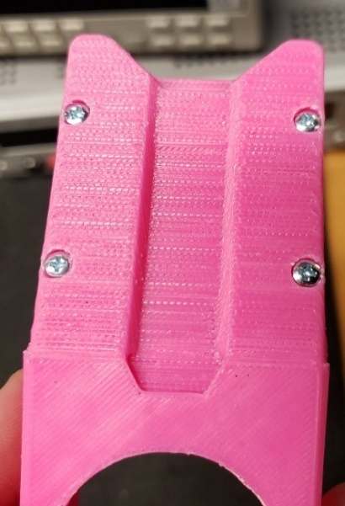

## Painting the 3D parts

If you did not print with black ABS filament, you can simply apply a light coat of black matte finish spray paint the 3d prints from multiple angles. Let them dry for a few minutes before applying another coat. It’s important you do a light coat; it will look better doing multiple light coats than one heavy coat that can leave drip marks or another unwanted residue. You will probably want to apply multiple coats and I found that it is easiest to do one side at a time so that you can get the spray paint in all the crevices and features. Be sure to paint the pieces BEFORE you assemble. But if you make a mistake or miss a spot, simply spray the paint onto a brush or Q-tip and lightly apply the paint to the desired area. It shouldn’t affect the overall look of the piece. This is also helpful if after gluing there is residue that is now shiny, you can use the above-mentioned touch-up method to make it matte black and fit right in.

# Electronic Circuit

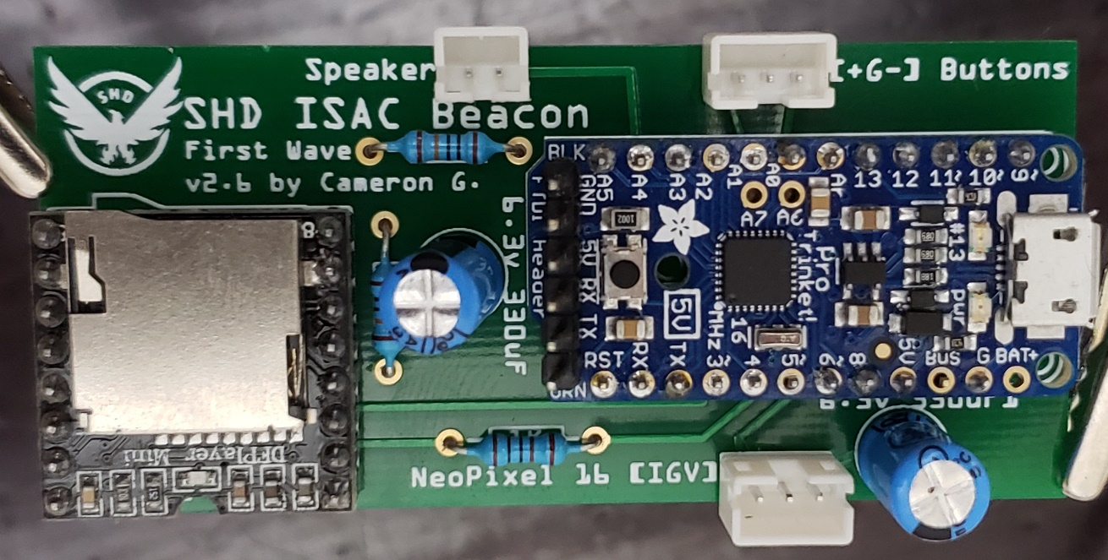

What makes the First Wave ISAC Beacon unique is the custom integrated circuitry and software that allow the unique visual and audio effects to be played.

Have the supplied circuit board that I designed is not required, but it sure simplifies a lot of the soldering and circuitry work. I found that the most inexpensive place to print them was through <https://jlcpcb.com/>. You can print 5 for around $2 or $7 for a lead-free version. Cost of shipping is around $16 to get them in about a week, or $6 if you don’t mind waiting 2-3 weeks. If you place an order possibly coordinate with the community to see if anyone else would like to split the cost and send them a board.

## Specific circuit elements

If you plan to design your own circuit board, you can follow the design diagrams and breadboard layouts to see how the circuit is laid out. Below are a few key notes of the design of the circuit board and how they affect the overall function of the First Wave ISAC Beacon.

### Capacitors

There are 2 capacitors in the circuit that sit between the Adafruit Pro Trinket, the DFPlayer audio controller, and the NeoPixel ring along the Ground and 5V power pins. This was for two reasons.

1. It is recommended to have a capacitor before a NeoPixel to protect the LEDs from voltage surge at startup
2. Eliminate the electronic hum or noise that the NeoPixel LEDs were causing to be heard from the speaker. The higher capacitance the lower the sound got, I found that putting 2 330uF capacitors eliminated the interference noise completely. To save on size, I went with a 6.3v version as the circuit is only running at 5v.

### Resistors

Per the diagrams of the DFPlayer a 1K ohm resistor is needed along the pin that will be transmitting the commands to the audio module.

The two 100K resistors help make the ISAC chatter / talking effect of the LED ring work. To make that feature possible I needed to know the level of current going to the speaker and then change the brightness of the LEDs based on the level of current. Higher current means louder noises, which means it is talking and should be brighter. The resisters sit between the speaker’s power line where a branch then goes to the analog input pin A4 of the Adafruit trinket. By putting this line between two high resistors that are then each connected to the Ground and 5V wires in the circuit make the signal possible to be read as an analog value which I use to change the brightness. For more about the chatter effect, see the code for the effect. It was not a straight 1 to 1 on how to set the brightness and the changing of volume up and down can change the values. Therefore, we must calculate what the ‘normal’ or steady silent level on the pin is and then based on volume and % from a norm how bright to make the effect. Honestly, I just tried multiple values and calculations until the algorithm felt ‘right’ and worked well enough at the different volume levels.

## Soldering considerations

It isn’t necessary to solder all connecting pins of the Adafruit Pro Trinket and the DFPlayer, only the ones that are used in the circuit. See the following pictures for easy reference to those pins.

* Adafruit Pro Trinket 5V: 3, 4, 5, 5V, G, A0, A1, A4
* DF Player (pins on left side from bottom): 1, 2, 3, 6, 7, 8

Required solder points / pins are identified with yellow arrows. Optional solder pins are circled in orange (FTDI port on Trinket Pro, one pin on DFPlayer for stability). Note, in the picture above the capacitor and resistor pins are not yet trimmed, you should do that after soldering.

When soldering the pins onto the Adafruit trinket pro (because it doesn’t come with pins pre-soldered. I recommend having the longer part of the pins sticking out of the top of the board as seen in the picture above. That way it keeps the bottom of the board shorter and you won’t have to trim the top of the pins off to make sure it fits in the housing. This also works well for putting the FTDI pins if you plan to customize the code and debug the software.

The pins on the DFPlayer once soldered can be trimmed so that the circuit doesn’t take up as much space, but that is optional if it fits for your needs. You should trim off the ends of the resistors and capacitors to ensure a good fit.

You can solder the speaker, push buttons, and NeoPixel wires directly to the custom PCB instead of putting the JST 2 and 3 pin male connectors listed in the parts section. I just found that as I was prototyping and testing it was convenient to be able to unplug the whole module from time to time.

## Deploying the software and audio files to the circuit

The First Wave ISAC Beacon uses an Arduino compatible controller called the Adafruit Pro Trinket 5V. Deploying the supplied software onto the circuit board is simple and does not require advanced knowledge of software development or circuitry. The steps below should allow you to upload the custom software for the ISAC beacon and configure the audio files on your SD card to be ready to use.

Get the First Wave ISAC Beacon’s software from GitHub:  
<https://github.com/WedgeTheJedi/First-Wave-ISAC-Beacon>

### Install the Arduino IDE, NeoPixel, and DFPlayer libraries

Download the latest Arduino IDE from here: <https://www.arduino.cc/en/Main/Software>

You can add the NeoPixel and DFPlayer libraries to your IDE by either downloading and installing them manually from GitHub or you can use the Library Manager in the Arduino IDE.

<https://github.com/adafruit/Adafruit_NeoPixel>  
<https://github.com/DFRobot/DFRobotDFPlayerMini>

To install them from the Arduino IDE (easiest) open the First Wave sketch file and then select Sketch -> Include Libraries -> Manage Libraries.

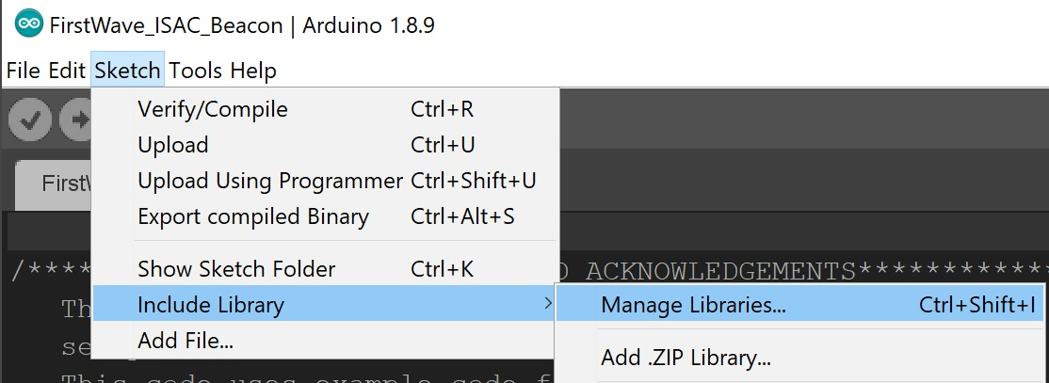

Then do a search for the following libraries from the manager and install them

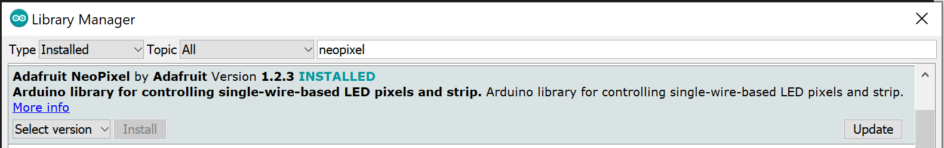

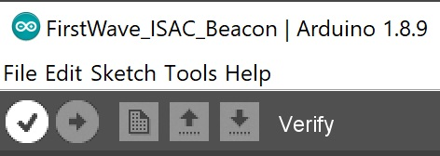To verify you have the libraries properly installed press the verify / compile button in the Arduino IDE You should see a result like the following if it compiled correctly and is ready to be deployed to the Adafruit Pro Trinket.



### Deploying the software to the Adafruit Pro Trinket

You will first need to download the drivers to add the Adafruit Pro Trinket to your board manager. Those can be downloaded here: [Windows Driver Installation | Introducing Pro Trinket | Adafruit Learning System](https://learn.adafruit.com/introducing-pro-trinket/windows-setup)

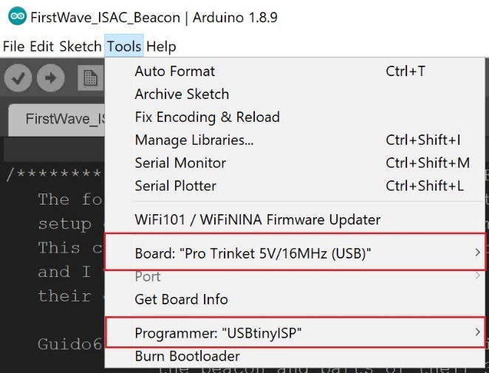If using the USB port without the FTDI module, open the Tools menu and set the following:

* Board – Pro Trinket 5V/16MHz (USB)
* Programmer: USBtinyISP

When using the USB port and not the FTDI module, you must either plug in the Trinket Pro or hit the reset button on the Trinket Pro and then immediately click the Upload button. Otherwise the software won’t upload during the Trinket Pro’s boot sequence.

If you are using the optional FTDI module, you don’t have to reset the board to upload, but you must set the following settings in the Tools menu. Also select the port that the FTDI connection shows up on and then click the Upload button.

* Board – Pro Trinket 5V/16MHz (FTDI)
* Programmer: AVRISP MkII

### Copy audio files to the Micro SD card

The DFPlayer indexes the audio clips on the SD card based on the time they were copied to the card and *not* based on filename. Therefore you must copy the audio files in order onto the SD card or else the audio clips will not line up to the programmed IDs resulting in the wrong clips playing. To simplify this I’ve create a copy script that is included with the audio files. To properly use the script, insert your SD card into your computer and note which drive letter it is given (on my PC it was drive D:\). Edit the CopyAudioClips.cmd file to change D:\ to be whatever your SD card’s directory is. Save the .cmd and then run it from a command line. This should copy the files in order one by one to the SD card. Put the SD card into the DFPlayer and test the circuit.

### Testing the circuit

If you opted to use JST cables and connectors you can simply plug in the speaker and the NeoPixel. If working properly the NeoPixel should make startup effects as seen in the preview videos. Also, you should hear audio from the speaker. If you have the ability to wire up two buttons from a beadboard you can test the other functionality or plug them into the buttons on the housing if installed as outlined below.

# Assembly

## ISAC Light Ring

First, place the ring midplate (the disk) on a hard, flat surface like a table. Then place the ring window piece over that. Finally place the main housing of the ISAC Beacon upside down over those so that they fit on the top of the housing. As seen below

Next, press midplate disk against the hard surface and then push the ring’s window down. When done, the top of each of the 3 pieces should all be flush along the top as seen in in the picture below. If they are not flush, adjust as needed using the hard surface until they are in alignment. The fit should be tight, and the pieces should stay together once lifted off the hard surface.

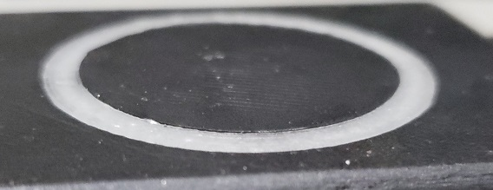

Before gluing the pieces into place, you should ensure that the ring window, midplate, and diffuser all fit into the housing snug and flat. If there are parts of the 3D print that are preventing that you may want to sand them down until the fit is more perfect. Not having the diffuser flat will cause the light ring to be uneven in brightness around the ring.

Once the pieces of the light ring are aligned with the top of the beacon, place top down again on the hard, flat surface. Using a hot glue gun, apply a small amount of hot glue as seen in the picture below across the ring window and in the middle to secure the midplate to the diffuser. Do not put a lot of glue around the ring, using just a little bit prevents the glue from pushing up through the top of the light ring when you put the diffuser on. While the glue is still hot, place the diffuser into the assembly as seen below. When pressing down, make sure you are on a hard, flat surface to prevent the top ring pieces from shifting or popping out of alignment. Apply additional hot glue as needed around the diffuser’s edge, but not on top of it.

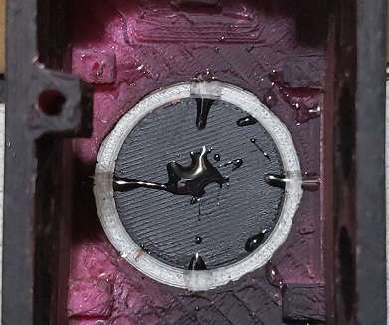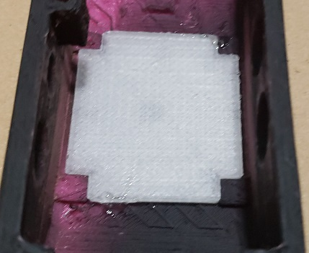

Place the NeoPixel into the baseplate as seen below. Note that on the NeoPixel there are small nubs at the top, bottom, and both sides. The baseplate has groves on the top and bottom to fit these and help with placement. You will need to sand down the nubs on both sides to ensure a good fit into the ISAC housing. The pixel that should be at the top is the one just to the left of the OUT pin on the NeoPixel. (See pictures below). You can verify the top pixel by plugging the NeoPixel into the circuit board and turning it on. The boot up effect should light with that pixel first and then light up the other pixels in clockwise order as seen below.

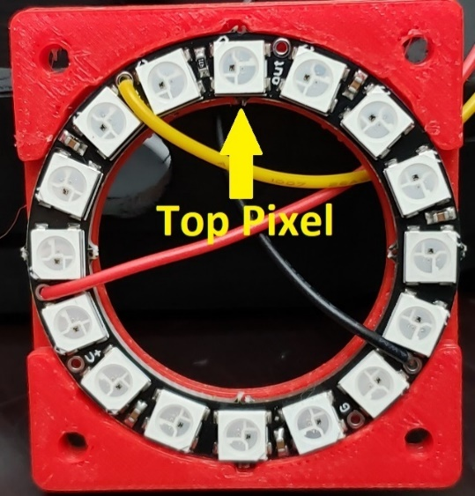

You can place a tiny amount of glue onto one or both sides of the ring to secure it to the baseplate, but I did not find that is needed as the fit when inserted is tight. Make sure that the top pixel as shown above is towards the front of the ISAC beacon. The fit for the midplate should be tight and you may need to sand or smooth either the inside of the housing or the midplate sides to make it fit properly. You want this snug and not loose. Turn on the NeoPixel by plugging it into the circuit and then slightly adjust it so that there is a nice uniform light around the entire light ring. If it is shifted too far up or down, you will notice the LED’s directly under the window and it won’t look as good.

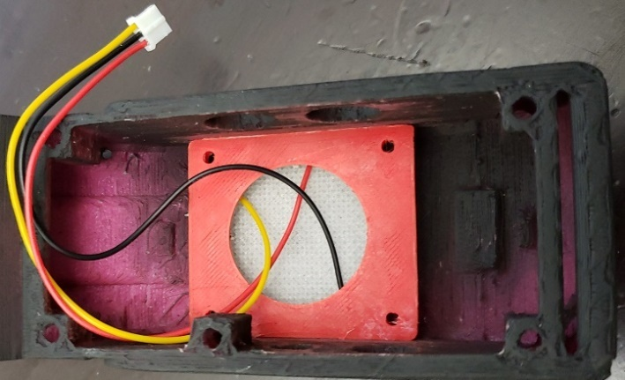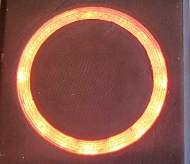

You can now place a small amount of hot glue on the corners of the baseplate if you want, but it should be snug enough that it should not be needed.

Once everything is in place, you will want to cover the light ring’s baseplate and sides with black electrical tape to prevent light from leaking into the ISAC beacon and shining through any small spaces between the printed parts. Do this by following the picture examples below making sure to have the connecting wires come out of the side (to prevent light from leaking through their own opening). Turn on the ring in a dark room and continue to add parts of tape until all or most of the light from the ring doesn’t leak into the housing.

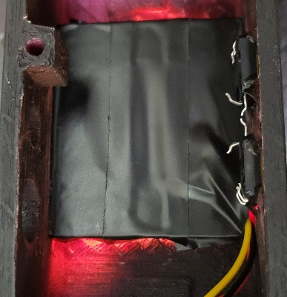

(Right) Light leaking out of the top and bottom left  
(Left) added tape to block the light

## Push Buttons

Before you install the push buttons you must install the light ring parts or else it will be very difficult to get the NeoPixel base plate into position. Once the light ring is installed, you can epoxy the push button switches into place. Hot glue may work, but epoxy will be stronger since you will be pushing against the buttons. Simply prop the main housing on its side with the left side down where the (+) and (-) buttons will go. Make sure that the pins for the switches are close together as we will create a bridge between both switches for the ground wire later. See pictures below for example placement.

Test the buttons in place first by holding them against the housing and making sure the buttons are able to click (with the button caps on) without getting stuck on the sides of the main housing. If they do not click freely, adjust them or file / smooth out the holes as needed.

Mix a small amount of epoxy and put a small drip on each corner of the switches to make sure the glue or epoxy reaches the main housing and over the corner of the switch to firmly hold it in place. Using too much may drip down onto the switch’s cap and prevent the button from being pressed, so only use a little bit. See the picture below for an example.

Once the glue has dried, bend the bottom middle pin on each switch outwards so that they are almost touching each other. This will be used as our common ground connection. The Pins just above these will be the ones we use to complete the circuit. Bend all other leads inwards towards the switch. one lead from each switch in the middle over so that they are almost touching as seen in the picture below.

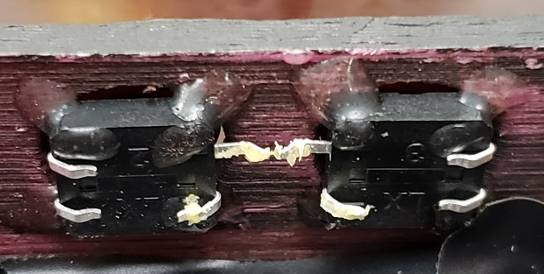

(note the pins in the picture above have flux on them to help with soldering, this is optional)

Once the pins are in position, solder the two ground pins together and add the ground wire to their connection. Then solder the (-) button wire and (+) button wire appropriately to the pins directly under the ground pin connection as seen here. Note, you can use whichever color wire you want on either switch. It just depends on how you oriented your connector port on the circuit board. In the picture below I connected the red wire to the (+) button and the yellow wire to the (-) button. If the wires get mixed up simply unsolder, swap, then re-solder them.

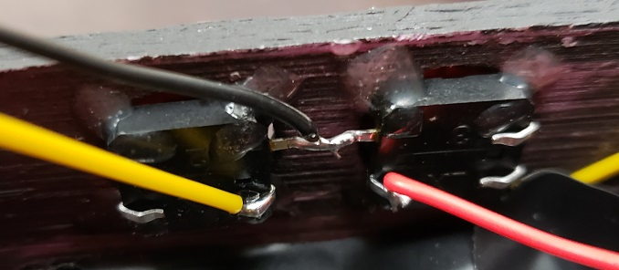

If you have black button caps, then you can just leave those on if you like. Or you can go one step further and add texture and markings to indicate the (+) and the (-) button. For this I used a Dremel with a saw blade and then cut a shallow ‘-‘ and ‘+’ onto the buttons as seen below. I then spray painted them with the matte black used on the housing to match.

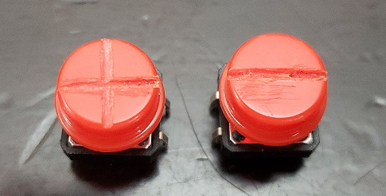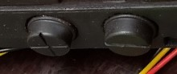

## Speaker

The speaker recommended in the parts list fits perfectly into the front housing of the ISAC beacon and is pre-wired with a connector. To fit the speaker into place, simply slide it over the screw posts and rest it into the front cavity of the main housing as seen in the picture below. It may move around and you can glue it down if you want, but it is secure and won’t slip out.

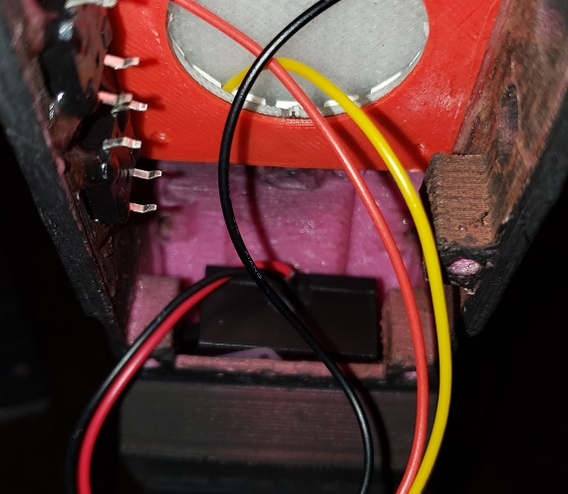

## Antenna

Take 13” of aluminum ½ inch measuring tape and cut the end tip to be round. Next cut 14 inches of heat shrink wrap.

Place the measuring tape inside the shrink wrap leaving about ½ inch on the end tip. Start heating up the end with a blow drying or preferably a crafts heat gun. Squeeze the end so that it creates a seal just before the rounded tip on the measuring tape. Heat shrink down the tube until you have about 1 ½ - 2 inches left of shrink wrap as seen below

Next cut a ½ inch of your shrink wrap to use as a band to secure the bend of the antenna. If you are using ½ inch shrink wrap it might not be possible to fit over the bend. In this case, I recommend using black electrical tape to create the antenna band.

Fold the antenna backwards then loop the end inside and adjust the ends so that it looks like this. Use your hand to hold down the spot where the band will go. You want the bottom loop to be just in front of where the antenna will connect to the arm.

Slide or place the band in the position of the finger above and then secure it down to keep the antenna bent in that position. If using heat shrink, you will need to pinch the antenna and then use the heat gun to shrink the band to hold it in place. You may want to use a clip or heavy gloves as to not burn your fingers.

When done, the antenna should look like this.

## Antenna Arm

Note: Before you attach the antenna arm to the main housing, you should have already installed the light ring parts, otherwise that step may be more difficult.

Sand the middle part of the antenna main arm so that when you put them together, they make a nice flush connection. Then mix some epoxy together and place epoxy on the parts of the arm that will be touching and around the edges. Try not to fill the triangular hole at the front of the antenna, we will fill this with epoxy and the antenna later. Make sure to also fill the arm cavity and drip some epoxy onto the 8-32 x 1” black socket head screw. This screw should fit with a little bit of room in the center of the circular arm with the bolt sticking slightly out of the end. The more epoxy that fills this cavity and connects with the screw the more secure the arm overall will be.

Place the two pieces together and put a little bit of epoxy on the bottom end of the antenna where the sleeve / end cap goes. Your antenna arm should look like the picture below.

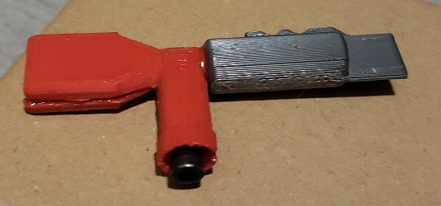

While the epoxy is still soft and not yet set, adjust the pieces so that they are as flush as possible and then attach clamps or hold them together tightly until the epoxy dries. In my case, I used 2 clamps to hold the arm and the antenna port tightly together.

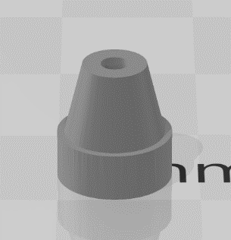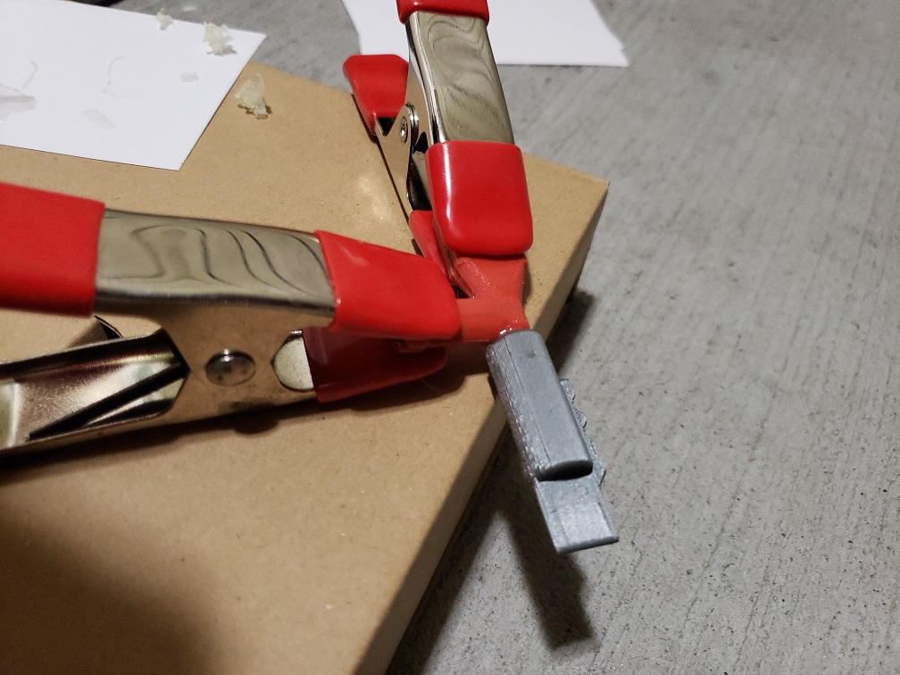

Once dry, finish the antenna arm with filler/primer, sand smooth, and then spray paint black like the main housing. You will also want to finish and paint the antenna cable port (the smallest 3D printed piece. Most 3D printers won’t leave the hole and will print over it. Simply take a Dremel or other drill and make a hole just big enough for your 22 AWG wire to fit into. This should be done before attaching the antenna arm or cable port to the main housing unit.

Once dried, finished, and painted mix more epoxy and fill the antenna rectangular cavity. Slide the end of the tape measure into the antenna port with the epoxy in it and settle it as far back as you can. Adjust it so that it is coming out of the antenna arm straight and then heat shrink the rest of the wrap so that it shrinks onto the arm as well. Let the epoxy dry to secure the antenna to the arm before securing the arm to the main housing.

Test fit the arm and the cable port into their corresponding holes in the main housing. They may be a little lose or fit tight, just make sure you can fit them in, and sand down the edges if you can’t. Mix a small amount of epoxy and lightly coat the rings of the holes in the main housing. The epoxy in this step is only meant to hold the antenna in place for the main epoxy glue we will do later. Adjust the arm’s positioning as needed until it looks straight and is not tilted. Place objects under the arm to secure it and hold it in that position until the epoxy has dried enough to hold it in place on its own. In my case, I used notecards to build up a base to hold the antenna flat.

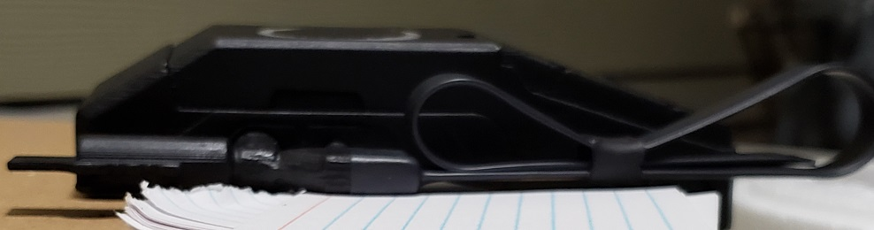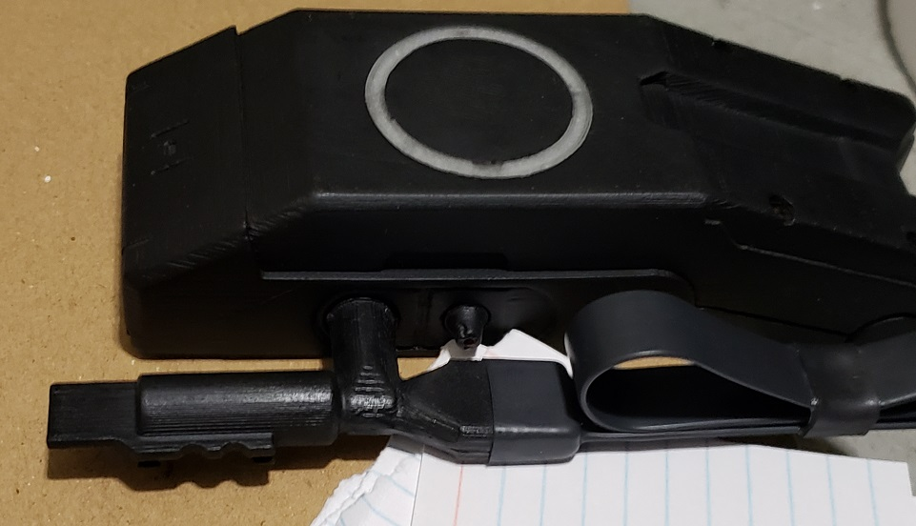

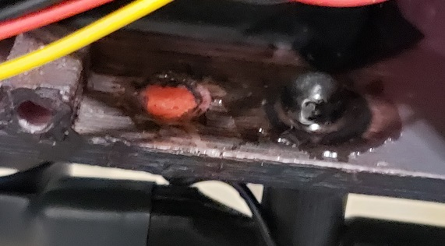Once this is dry so the arm doesn’t shift, you want to mix more epoxy and prop the unit up so that it is on its side with the antenna side down. This will allow you to then drip and coat the inside of the cable port and the antenna arm with epoxy to strengthen and secure them in place. Because the epoxy drips before it becomes more solid it is important to have the unit on its side so the epoxy stays on the back of the pieces. You want to make sure that the screw in the arm is also covered with epoxy to prevent it contacting the electrical components of the circuit.

## 

## Cable Port Wire

Cut a 12.5cm length of 22 AWG wire and then bend ½ cm of one end in a 90 degree angle so that it will fit into the cable port like the picture below. Put a small bit of epoxy on the end and place it into the cable port. NOTE you should have already drilled a hole into the cable port for the wire before attaching the antenn arm.

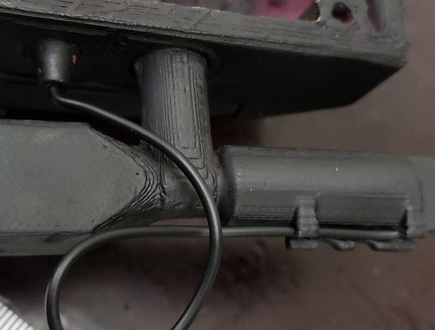

Loop the wire as shown below and then place another small amount of epoxy onto the arms that hold the wire down under the jaggy edge. This should secure the wire. Bend the wire as needed so it stays in this form and then let dry. (Note the picture below is the bottom of the ISAC beacon. The wire goes under the antenna arm.

## Circuit Installation

Simply plug in the connecting wires for the speaker, NeoPixel, and push buttons onto the circuit board (or solder them on if not using the JST connectors). Plug the USB cable into the circuit board and give the entire unit a final functional test before progressing.

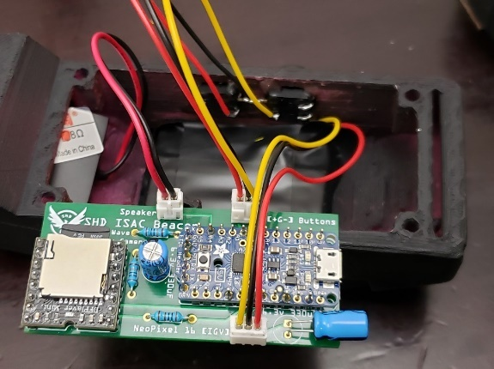

Once the unit is functioning properly and wired up, slide the side of the circuit with the USB cable in first as seen below. You will want to pre-bend the USB cable so that it fits properly and turns around to be able to come out the bottom of the housing with the baseplate on.

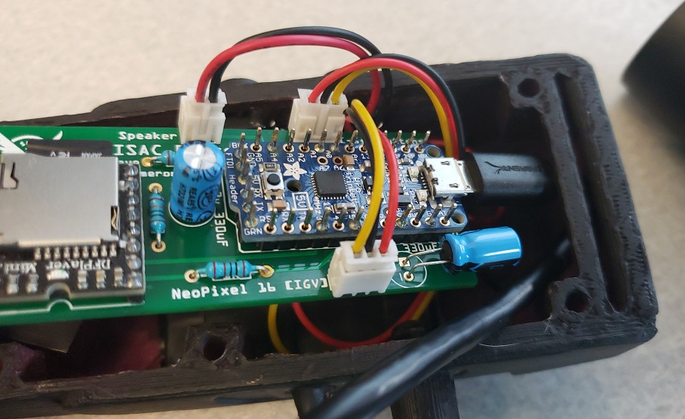

Now position the rest of the circuit and wires into the housing. Everything should fit comfortably in the allotted space and allow easy placement of the baseplate.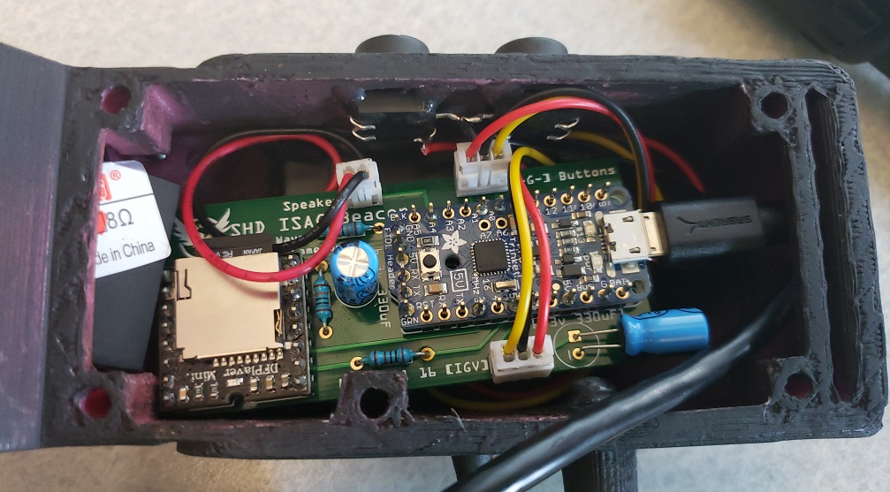

## Baseplate

If you are using the baseplate with the clip, simply mix some epoxy after the baseplate has been painted and glue it to the baseplate in the correct orientation (to the longest flat side of the baseplate) as seen below.

If you are using the baseplate with built in loops, no epoxy is needed.

Once your baseplate is finished, fit the USB cable through the opening and then line up the baseplate screw holes with the screw posts in the main housing. Insert the screws and screw them down snug, but not tight. If using the clip, you may not be able to use the middle screw hole which is fine.

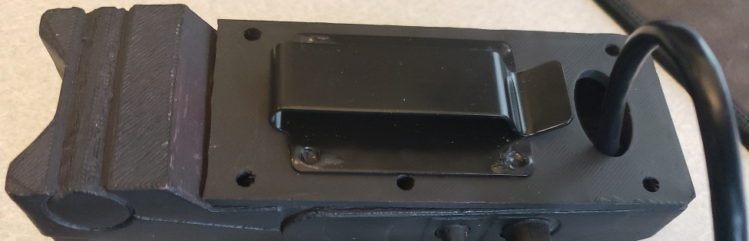

## Attaching to Backpack

Once fully assembled, use the Velcro straps to secure it to the right shoulder loop of the backpack. You can create loops and since down the Velcro straps or weave them into existing Molle webbing like I have on my bag. The beacon looks best when sitting closer to the backpack farther down on the strap, but be careful not to have it too low that during usage the bag will damage or snap the antenna pieces.

Thread the USB cable through the backpack’s water pouch or headphone hole (as most packs have them) and then connect it to a USB portable phone charger / battery to power the unit while wearing it.

